**LD50/LC 50 Interactive Activity**

Name

**Part 1 Parts Per Million**

MCj02321880000[1]

Parts per million - ppm - is commonly used as a measure of small levels of pollutants in air, water, body fluids, etc. It is the mass ratio between the pollutant component and the solution. PPM in the metric system is expressed as 1 mg/kg or 1 mg/L. Although PPM is a very small unit, they can cause serious health effects on animals and humans. Scientists can also detect parts per billion (ppb) and parts per trillion (ppt).

Ex - DO level below 3ppm will stress fish out.

Ex- Element silver is acutely toxic to aquatic organisms. The Florida Department of Environmental Protection has set a class III water quality criterion of < 0.07 ppb for silver.

**Objective**: Students will make a solution that represents a one part per million.

**Materials**: 7 small clear medicine cups food coloring

**Procedure**: Follow the amount below & fill in table

|  |  |  |  |  |  |
| --- | --- | --- | --- | --- | --- |
| Cup # | Water | Food Color | Ratio | Concentration | Percentage (%) |
| 1 | 11 ml | 5 drops | 1/1 | 1 part per 1 | 100% |
| 2 | 9 ml + 1 ml Cup#1 |  | 1/10 |  |  |
| 3 | 9ml + 1ml Cup#2 |  | 1/100 |  |  |
| 4 | 9 ml + 1ml Cup#3 |  | 1/1000 |  |  |
| 5 | 9 ml + 1ml Cup#4 |  | 1/10,000 |  |  |
| 6 | 9 ml + 1ml Cup #5 |  | 1/100,000 |  |  |
| 7 | 9 ml + 1ml Cup #6 |  | 1/1,000.000 |  |  |

**Part II LD 50**

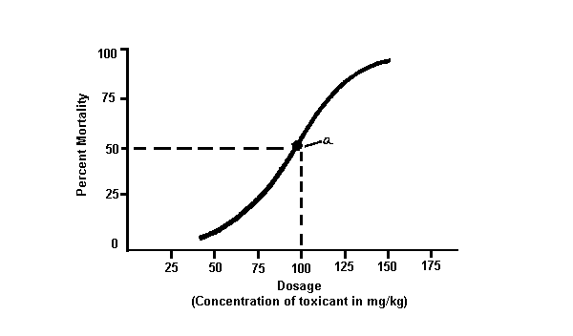

One of the methods that scientists can use to determine the toxicity of a chemical compound is an LD50/LC50 test. This test involves introducing different dose levels of the compound to be tested to a group of experimental subjects. The most commonly used experimental subject is lab rats or mice, because they have many physiologic similarities to humans. Above is a Dose Response Curve.

LD50 is defined as the lethal dose to 50% of the population. LC50 is defined as the lethal concentration to 50% of the population. By analyzing the LD50 for a compound and comparing it to other known samples, scientists can get a good measurement of how dangerous it would be to the human population.

1. Consider the LD50 graph of Drug a above? What is the LD 50 of Drug a?
2. A different drug is tested and found to have an LD50 level of 5 mg/kg. Would you consider this drug to more or less dangerous than Drug a?

**Next, visit the internet site below and complete the LD50 Virtual Lab on Brine Shrimp:**

<http://schoolcenter.k12albemarle.org/education/page/download.php?fileinfo=TEQ1MF8yMDExLnN3Zjo6Oi93d3c3L3NjaG9vbHMvdmEvYWxiZW1hcmxlY291bnR5L2ltYWdlcy9kb2NtZ3IvMTE5NzRfZmlsZV80MDk2NF9tb2RfMTMxODI5MTMwNS5zd2Y=&sectiondetailid=67446>

|  |  |  |  |
| --- | --- | --- | --- |
| Solution | Number  Dead | % Mortality  5 per tube | http://www.biologycorner.com/resources/graph_blank04.jpg  **What is the LD 50? – (x-dose, y % mortality)** |
| 100% |  |  |
| 10% |  |  |
| 1% |  |  |
| .1% |  |  |
| .01% |  |  |
| 0 |  |  |

**Part III Poisons and US**

Visit the following website:

<http://www.freya.u-net.com/risk/ld_frame.html>

1)Calculate your weight in kilograms (kg) (CALCULATOR ON WEBSITE ABOVE)

2)Input the LD50 for the following compounds and write below how many grams you would have to eat to risk a 50% chance of death:

a)Table Salt

b)Aspirin

c)Nicotine

d)Codeine

3)VX Nerve Gas has an LD 50 (mg/kg) of .0023. What does this value suggest? To calculate how much you would need to ingest to risk a 50% chance of death. Calculate the value above by multiplying your mass in kilograms x LD50 and divide by 1000 to convert to grams. What is value?

4)Complete Graph by utilizing the information on the table regarding a sample of people who ingested **Arsenic.** Plot the dose (x axis) by the death rate (y axis).

|  |  |  |
| --- | --- | --- |
| **Dose (mg/kg)** | **Death Rate(%)** | http://www.biologycorner.com/resources/graph_blank04.jpg  **WHAT IS THE LD50 (mg/kg) ?** |
| 2 | 1 |
| 4 | 2.8 |
| 6 | 5.2 |
| 8 | 10.4 |
| 10 | 19.5 |
| 12 | 34.2 |
| 14 | 62.3 |
| 16 | 94 |
| 18 | 100 |